**UDACITY DATA ANALYST NANODEGREE**

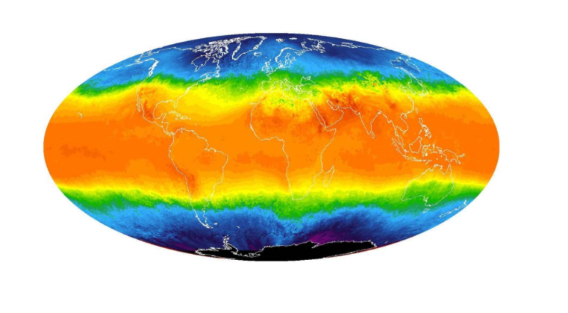

**Project Name: Explore Weather Trends**

*By : Bharath C S*

*Date: 16th April,2020*

**Progress outline:**

**1. What tools did you use for each step? ( Python,SQL,Excel,etc)**

a. I used two SQL queries to extract required data from data base, queries are as follows:

i. Global Data:

SELECT * FROM global_data ;

ii. Local Data : ( Austin, USA)

SELECT year,city,avg_temp

FROM city_data

WHERE city = ‘AUSTIN’ ;

The closet city is Austin so I took that data from database

b. The data has been analysed using Python Programming Language using IPYTHON Notebook ( Jupyter)

c. The downloaded file is imported as shown:

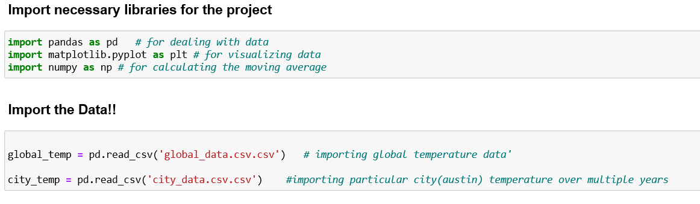

Page 1

**2. How did you calculate the moving average?**

* Rolling average has been calculated to smooth out data and to make it easier to observe the trends when it be shown in charts.
* The rolling average has been calculated for every 10 years to each single data but the first 10
* Python was used for calculating the Moving Average using built-in functions such as rolling,mean.
* Python code for what has been explained

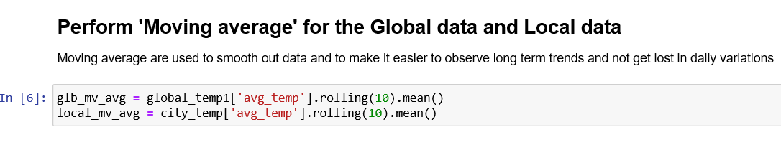

**3. What were your key considerations when deciding how to visualise the trends?**

The key consideration was to determine in the timeframe for data visualisation. Looking at the local temperature data for Austin, the data covers period between **1825** to **2013** , where in the global temperature data covers the period between **1750** and **2015.** Therefore, the analysis was performed for the range between **1825** to **2013.** To map local and global temperature data the above method is used it is shown as below:

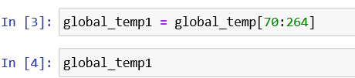

Page 2

**Line chart is as follow:**

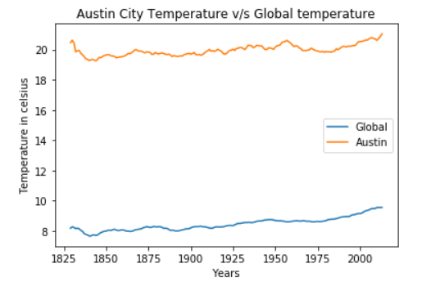

**Austin city temperature v/s Global temperature**

**The other charts are as follows:**

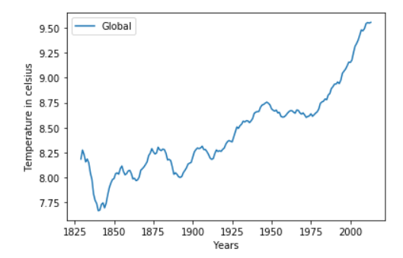

**Global average temperature**

Page 3

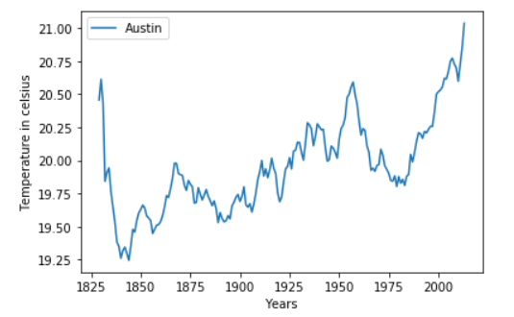

**Austin city average temperature**

**Observations:**

* By noticing the chart it shows that the temperature is raising over the years due to climate change.
* The Global temperature started to raise ‘exponentially’ since the middle of 1800 which happened to be the same data as oil mining
* Since 1975 the temperature is raising without any stops
* The difference between year 1800 and ~ 2010 in temperature is more than 2 degrees in the global average chart ( increasing)
* The difference between year 1800 and ~ 2010 in temperature is more than 3 degrees in the Austin city average chart ( increasing)
* Austin city temperature dropped in 1975 then started increasing
* Austin city is getting hotter over time
* The change of the climate between Austin and globe is slightly small, both are of them are increasing.

Page 4